CNN Baseline Model

# 8_trail_1

Threshold 0.8

model = CNN1()

model.to(device)

summary(model, (3, 256, 256))

train_net(model, learning_rate=0.0005, num_epochs=10, batch_size = 32, train_loader = train_loader, val_loader = val_loader, test_loader = test_loader)

#model_path = model_name("1.0", batch_size=64, learning_rate=0.0005, epoch=)

#plot_training_curve(model_path)

class CNN1(nn.Module):

def __init__(self):

super(CNN1, self).__init__()

self.name = "1.0"

self.conv1 = nn.Conv2d(3, 16, 12, stride=4, padding=4)

self.pool = nn.MaxPool2d(2, 2)

self.conv2 = nn.Conv2d(16, 32, 6, stride=2, padding=2)

self.conv3 = nn.Conv2d(32, 64, 3, stride=2, padding=2)

self.fc1 = nn.Linear(4 * 4 * 64, 32)

self.fc2 = nn.Linear(32, 7)

def forward(self, x):

x = self.conv1(x) # 256 -> 64 -> 32

x = self.pool(x) # 64 -> 32

x = self.conv2(x) # 32 -> 16

x = self.pool((self.conv3(x))) # 16 -> 10 -> 4

x = x.view(-1, 4 * 4 * 64)

x = self.fc1(x)

x = self.fc2(x)

x = x.squeeze(1)

return x

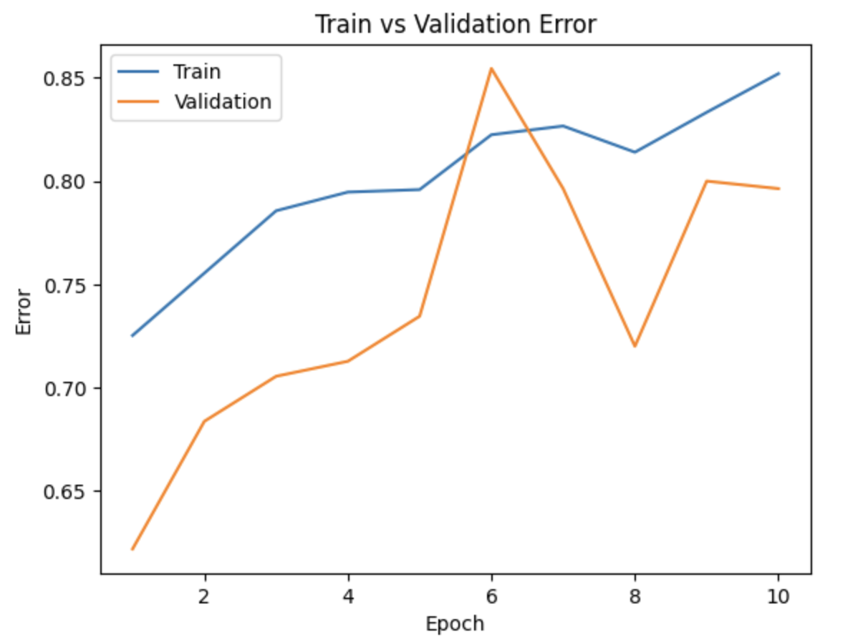

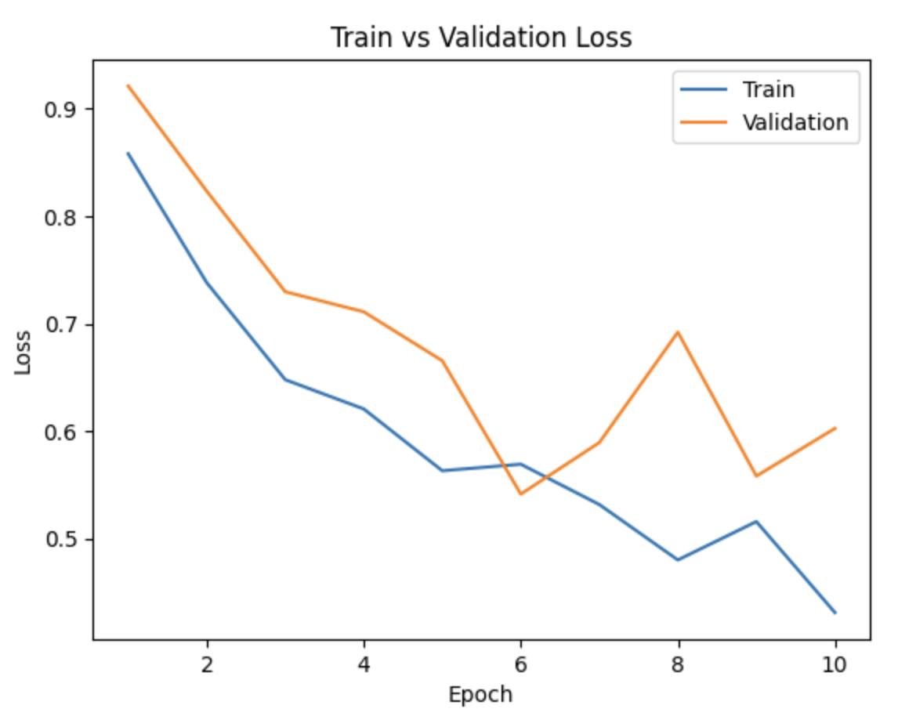

Training Start:

Epoch 1: Train Accuracy: 0.7252415458937198, Train Loss: 0.858001573727681 |Validation Accuracy: 0.6218181818181818, Validation Loss: 0.9210017124811808

Epoch 2: Train Accuracy: 0.7554347826086957, Train Loss: 0.7380476828951102 |Validation Accuracy: 0.6836363636363636, Validation Loss: 0.8232138289345635

Epoch 3: Train Accuracy: 0.7856280193236715, Train Loss: 0.6477822168515279 |Validation Accuracy: 0.7054545454545454, Validation Loss: 0.7296245098114014

Epoch 4: Train Accuracy: 0.7946859903381642, Train Loss: 0.6205571273771616 |Validation Accuracy: 0.7127272727272728, Validation Loss: 0.710976951652103

Epoch 5: Train Accuracy: 0.7958937198067633, Train Loss: 0.563056907401635 |Validation Accuracy: 0.7345454545454545, Validation Loss: 0.6654216084215376

Epoch 6: Train Accuracy: 0.822463768115942, Train Loss: 0.5691426190046164 |Validation Accuracy: 0.8545454545454545, Validation Loss: 0.5413413378927443

Epoch 7: Train Accuracy: 0.8266908212560387, Train Loss: 0.5316115228029398 |Validation Accuracy: 0.7963636363636364, Validation Loss: 0.5892468525303735

Epoch 8: Train Accuracy: 0.8140096618357487, Train Loss: 0.4800498216198041 |Validation Accuracy: 0.72, Validation Loss: 0.6919616593254937

Epoch 9: Train Accuracy: 0.8333333333333334, Train Loss: 0.5157467688505466 |Validation Accuracy: 0.8, Validation Loss: 0.5581217408180237

Epoch 10: Train Accuracy: 0.8520531400966184, Train Loss: 0.4311694654707725 |Validation Accuracy: 0.7963636363636364, Validation Loss: 0.6024096012115479

Final Train Accuracy: 0.8520531400966184 Final Train Loss: 0.4318474313387504

Final Validation Accuracy: 0.7963636363636364 Final Validation Loss: 0.6011804209815131

Final Test Accuracy: 0.825 Final Test Loss: 0.6375317739115821

# 9_trail_1

Threshold 0.9

model = CNN1()

model.to(device)

summary(model, (3, 256, 256))

train_net(model, learning_rate=0.0005, num_epochs=15, batch_size = 32, train_loader = train_loader, val_loader = val_loader, test_loader = test_loader)

#model_path = model_name("1.0", batch_size=64, learning_rate=0.0005, epoch=)

#plot_training_curve(model_path)

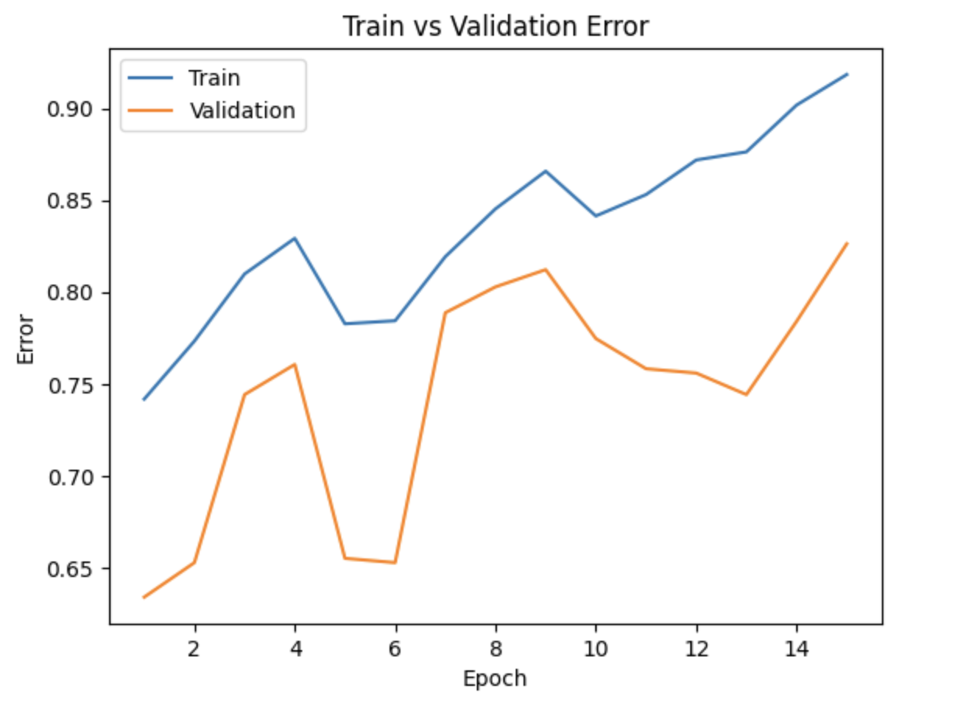

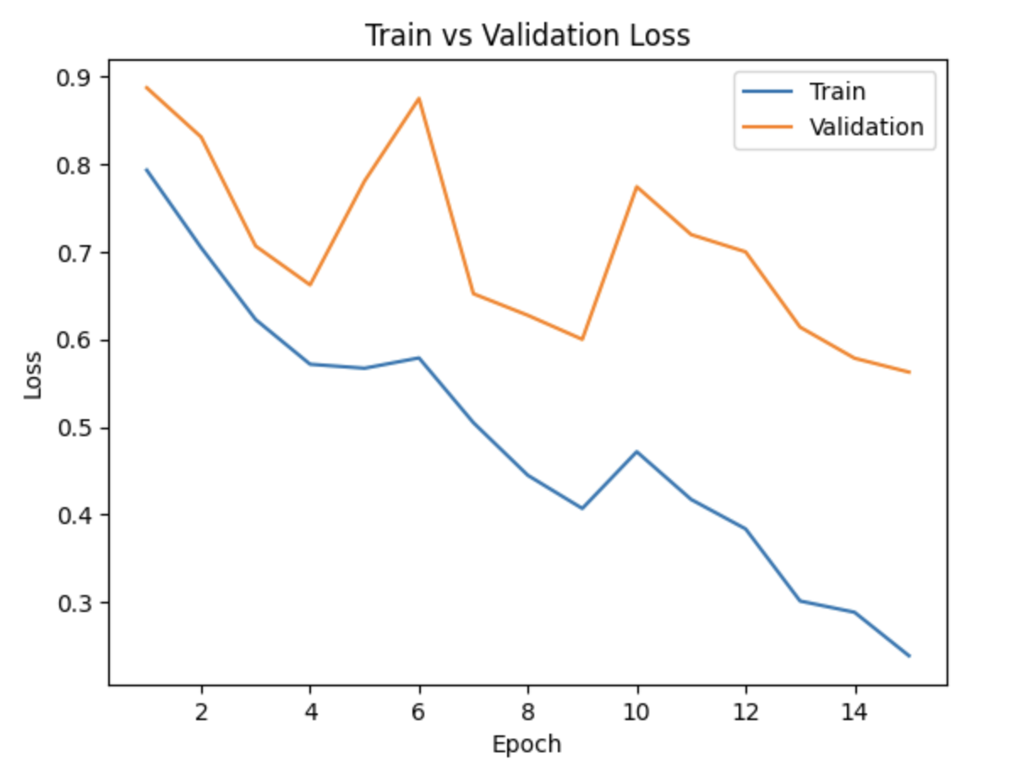

Final Train Accuracy: 0.9185144124168514 Final Train Loss: 0.24001991265175635

Final Validation Accuracy: 0.8262910798122066 Final Validation Loss: 0.5650495503629956

Final Test Accuracy: 0.840958605664488 Final Test Loss: 0.46529548267523446

Training Start:

Epoch 1: Train Accuracy: 0.7416851441241685, Train Loss: 0.7931598534709529 |Validation Accuracy: 0.6338028169014085, Validation Loss: 0.8871887411390033

Epoch 2: Train Accuracy: 0.7732815964523282, Train Loss: 0.7045510724971169 |Validation Accuracy: 0.6525821596244131, Validation Loss: 0.8308700280530112

Epoch 3: Train Accuracy: 0.8098669623059866, Train Loss: 0.6225375731786092 |Validation Accuracy: 0.744131455399061, Validation Loss: 0.7064669451543263

Epoch 4: Train Accuracy: 0.8292682926829268, Train Loss: 0.5715187537042719 |Validation Accuracy: 0.7605633802816901, Validation Loss: 0.6620990612677166

Epoch 5: Train Accuracy: 0.7827050997782705, Train Loss: 0.5669383139986741 |Validation Accuracy: 0.6549295774647887, Validation Loss: 0.7806093863078526

Epoch 6: Train Accuracy: 0.7843680709534369, Train Loss: 0.5787382732357895 |Validation Accuracy: 0.6525821596244131, Validation Loss: 0.8749668640749795

Epoch 7: Train Accuracy: 0.8192904656319291, Train Loss: 0.5047843550380907 |Validation Accuracy: 0.7887323943661971, Validation Loss: 0.6520298336233411

Epoch 8: Train Accuracy: 0.8453436807095344, Train Loss: 0.4446750471466466 |Validation Accuracy: 0.8028169014084507, Validation Loss: 0.6273643629891532

Epoch 9: Train Accuracy: 0.8658536585365854, Train Loss: 0.4068029326827903 |Validation Accuracy: 0.812206572769953, Validation Loss: 0.5999274147408349

Epoch 10: Train Accuracy: 0.8414634146341463, Train Loss: 0.47164240270330193 |Validation Accuracy: 0.7746478873239436, Validation Loss: 0.7741771382944924

Epoch 11: Train Accuracy: 0.8531042128603105, Train Loss: 0.41709355722393904 |Validation Accuracy: 0.7582159624413145, Validation Loss: 0.7195291497877666

Epoch 12: Train Accuracy: 0.8719512195121951, Train Loss: 0.3834797917750844 |Validation Accuracy: 0.755868544600939, Validation Loss: 0.699817955493927

Epoch 13: Train Accuracy: 0.8763858093126385, Train Loss: 0.30115794782575805 |Validation Accuracy: 0.744131455399061, Validation Loss: 0.6139194071292877

Epoch 14: Train Accuracy: 0.9018847006651884, Train Loss: 0.288310923335845 |Validation Accuracy: 0.784037558685446, Validation Loss: 0.5783902513129371

Epoch 15: Train Accuracy: 0.9185144124168514, Train Loss: 0.2386425911334523 |Validation Accuracy: 0.8262910798122066, Validation Loss: 0.5625049131257194

# 9_trail_2

After accurate normalization

model = CNN1()

model.to(device)

summary(model, (3, 256, 256))

train_net(model, learning_rate=0.0005, num_epochs=15, batch_size = 32, train_loader = train_loader, val_loader = val_loader, test_loader = test_loader)

#model_path = model_name("1.0", batch_size=64, learning_rate=0.0005, epoch=)

#plot_training_curve(model_path)

Training Start:

Training Start:

Epoch 1: Train Accuracy: 0.7111973392461197, Train Loss: 1.003195951905167 |Validation Accuracy: 0.6267605633802817, Validation Loss: 1.2561693276677812

Epoch 2: Train Accuracy: 0.7328159645232816, Train Loss: 0.9134936615040428 |Validation Accuracy: 0.6291079812206573, Validation Loss: 1.144119871514184

Epoch 3: Train Accuracy: 0.738359201773836, Train Loss: 0.8581425913593226 |Validation Accuracy: 0.6291079812206573, Validation Loss: 0.9965895393065044

Epoch 4: Train Accuracy: 0.7727272727272727, Train Loss: 0.9018516148391523 |Validation Accuracy: 0.7323943661971831, Validation Loss: 0.9731786293642861

Epoch 5: Train Accuracy: 0.7727272727272727, Train Loss: 0.8201261230728083 |Validation Accuracy: 0.7065727699530516, Validation Loss: 0.8838831931352615

Epoch 6: Train Accuracy: 0.7372505543237251, Train Loss: 0.8761936860126361 |Validation Accuracy: 0.6408450704225352, Validation Loss: 0.9825135810034615

Epoch 7: Train Accuracy: 0.8076496674057649, Train Loss: 0.6268209605886225 |Validation Accuracy: 0.744131455399061, Validation Loss: 0.7089742996862957

Epoch 8: Train Accuracy: 0.8032150776053215, Train Loss: 0.5862214246339965 |Validation Accuracy: 0.7276995305164319, Validation Loss: 0.6838591205222266

Epoch 9: Train Accuracy: 0.7754988913525499, Train Loss: 0.6803674765846186 |Validation Accuracy: 0.7276995305164319, Validation Loss: 0.7194614772285733

Epoch 10: Train Accuracy: 0.823170731707317, Train Loss: 0.5910196529145826 |Validation Accuracy: 0.7347417840375586, Validation Loss: 0.6604331284761429

Epoch 11: Train Accuracy: 0.8314855875831486, Train Loss: 0.5908376731370625 |Validation Accuracy: 0.8051643192488263, Validation Loss: 0.6200992230858121

Epoch 12: Train Accuracy: 0.8181818181818182, Train Loss: 0.606133126375968 |Validation Accuracy: 0.7417840375586855, Validation Loss: 0.6847869540963855

Epoch 13: Train Accuracy: 0.8508869179600886, Train Loss: 0.4926808170582119 |Validation Accuracy: 0.8262910798122066, Validation Loss: 0.5131214346204486

Epoch 14: Train Accuracy: 0.8558758314855875, Train Loss: 0.4347624804889947 |Validation Accuracy: 0.8098591549295775, Validation Loss: 0.48231264629534315

Epoch 15: Train Accuracy: 0.8697339246119734, Train Loss: 0.4367791176365133 |Validation Accuracy: 0.8661971830985915, Validation Loss: 0.4974483975342342

Finished Training

Total time elapsed: 904.13 seconds

Final Train Accuracy: 0.8697339246119734 Final Train Loss: 0.44064196944236755

Final Validation Accuracy: 0.8661971830985915 Final Validation Loss: 0.5057781317404338

Final Test Accuracy: 0.8845315904139434 Final Test Loss: 0.417468848824501

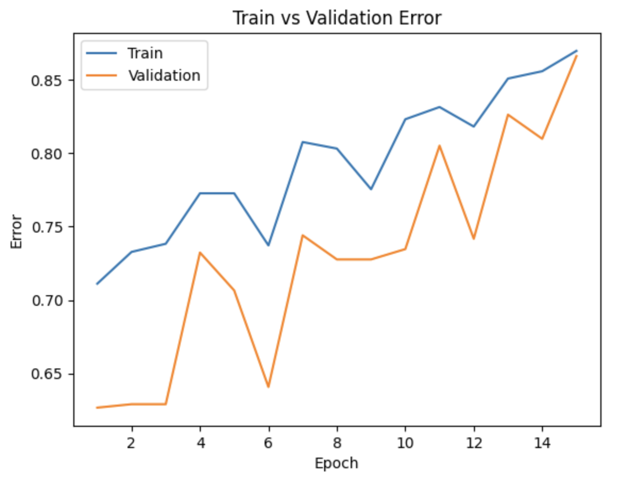

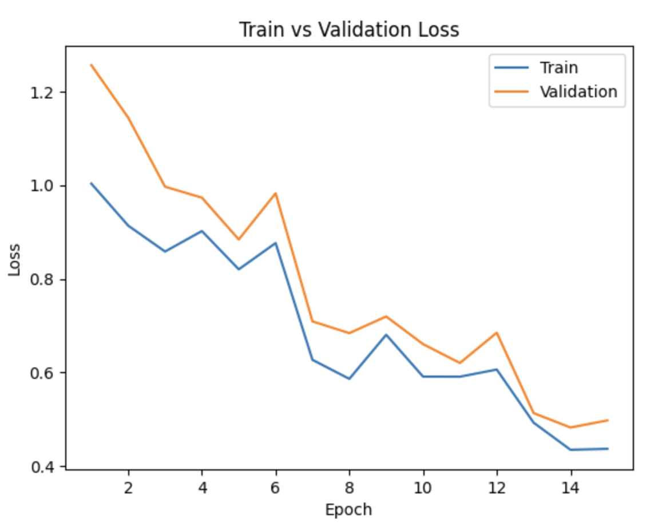

# 95_trail_1